**Programming Project Report**

Name: Blake Williams

Date: 2/1/2023

**Academic Integrity Statement:** I pledge that I have neither given nor received unauthorized help on this programming assignment.

**Problem Statement:**

The Goal of this assignment was to develop a interface that allows for storage of up to 10 pinball machines in a 2d array. The inputs of this project consisted of the user selecting which option they want from the menu. After selecting a menu each sub-menu has its own inputs that either display or alter the array. The major outputs consisted of displaying a specific pinball machine or displaying the entire array.

**Design:**

The design of this interface consist of three main files the pinball.h pinball.cpp and main.cpp. The pinball.h and pinball.cpp were designed to create the Pinball class and all of its methods, constructors, setters, and getters. Then in main 3 functions were designed to print the menu, add to the array, and read a txt file. Then a switch statement was utilized to allow the menu options to operate. In each case the appropriate code was implemented to allow for the user to select and run bits of code efficiently.

**Implementation:**

No sample code was provided, everything written is from scratch. In order to properly implement the design choices understanding of how utilities such as getline() and fstream were required for the majority of this code. The development timeline consisted of the planning phase where a rough sketch of what the main code would look like. After the planning phase skeleton methods were created in the pinball.h, pinball.cpp, and main.cpp. Once skeleton methods were inplace each skeleton method was “filled” in.

**Testing:**

Testing consisted of testing each case in the switch statement and fixing any issues that presented itself. Then once the cases were fixed the inputs consisted of creating a .txt file consisting of many pinball machines in the format that was provided. Then the cases of inserting a machine manually was tested. Everything worked as planned.

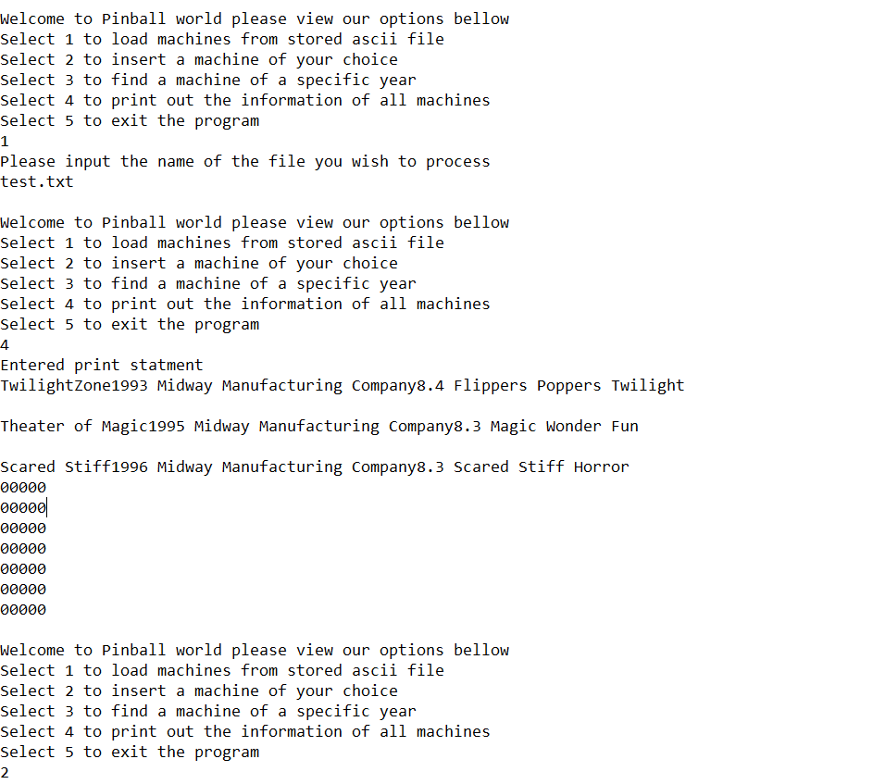

Fig1. Example input/output

**Conclusions:**

Overall this assignment was a success as the code operates within the parameters provided, and it was able to successfully generate a array and populate it with given txt files. This project took about 7hrs to fully complete including this report. If this project were to be expanded upon the function to delete editions to the array would be added, and instead of arrays vectors would be used to properly store entries into memory.